COMSTRAT 701 Capstone
Brand Audit & Refresh Prompt
PROMPT TEMPLATE

Your name: Paul Murphy

Part One: Company Overview
Name of the organization you have selected as the basis for your prompt | Rick Steves  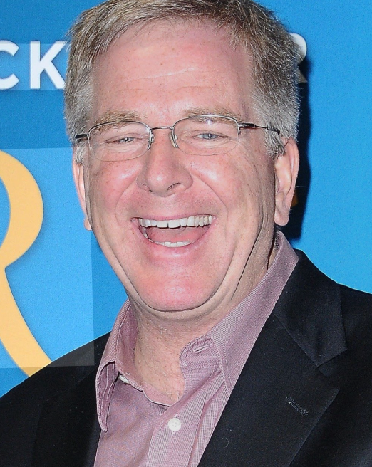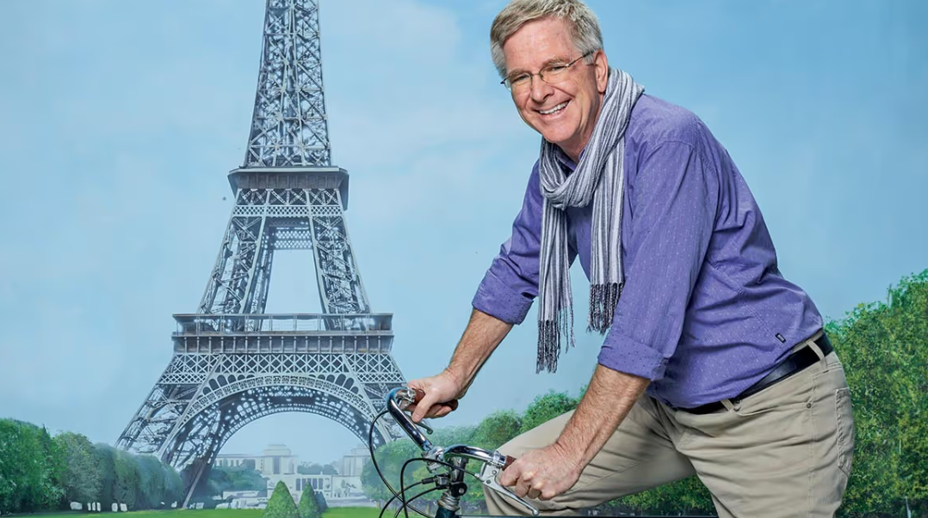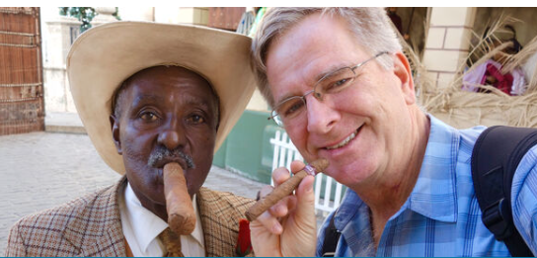
List their current digital channels | Website: https://www.ricksteves.com/  Facebook: https://www.facebook.com/ricksteves/  Instagram: https://www.instagram.com/ricksteveseurope/  Twitter: https://x.com/RickSteves?lang=en  TikTok: https://www.tiktok.com/@ricksteveseurope  Other: PBS Show:  https://www.pbs.org/show/rick-steves-europe/  Public Radio Show-Travel with Rick Steves
Describe the business in 1-2 sentences. Who are they? What do they do? Who do they serve? | Rick Steves an American travel guide who publishes books and content related mostly to traveling Europe. He is arguably the preeminent authority on European travel, with a PBS show, multiple published books and a steady stream of content on his media channels related to traveling Europe.  Rick’s brand is authentic and personable. He typically recommends destinations and experiences that are off the beaten path, so travelers can experience authentic culture and meet locals outside of established tourism hot spots.  Rick’s been publishing books since the late 70’s and his PBS show first aired in the year 2000, so his core audience is likely American retirees ages 55-80 with a passion for travel.  SOURCE: Wikipedia
Visit their website – do they have a mission and vision statement? If so – note it here. | About Page: Our mission is to inspire, inform, and equip Americans to have European trips that are fun, affordable, and culturally broadening. We value travel as a powerful way to better understand and contribute to the world in which we live. We strive to keep our own travel style, our world outlook, and our business practices consistent with these values.  SOURCE: ricksteves.com
When were they established or when did they first open their doors? | Rick Steves first published “Europe Through The Backdoor” in 1979 and has continued publishing updated versions since then. In the year 2000, he debuted his first PBS show “Rick Steves’ Europe”, which still airs today.  SOURCE: Wikipedia
Do they have a tagline? If so – please make a note | There is no established tagline, other than “Rick Steves’ Europe”
If you could choose 3-5 words to describe their brand, what would they be? | Authentic, fun, affordable, immersive travel
What would you say are the top 3 values of this brand? | - Cultural emersion  - Travel as education  - Authentic experiences over tourism

Part Two: Mini Brand Audit

Brand Inventory
Brand Promise | A brand promise is an expression of the benefits and value a company commits to consistently deliver to its customers. What is the company’s brand promise? What does it say about the company and its brand? e.g. BMW “the ultimate driving machine”, Nike “to bring inspiration and innovation to every athlete in the world” or Walmart “Save money. Live better. | Rick Steves offers cultured travelers tours, advice and recommendations to help them find the hidden gems of Europe and elsewhere. He believes travel should be fun and affordable, while also providing education through cultural exchange. Rick shares his passion for travel with his audience, guiding tours and introducing them to his favorite people and places, so they can continue their lifelong journey of learning through travel.
Brand Personality | What are the specific characteristics that are attributed to the brand? These are the behaviors and traits that people can relate to and help build a personal connection to the brand. There are five main dimensions of brand personalities: excitement, sincerity, ruggedness, competence and sophistication. | Sincerity is Rick Steves’ strongest brand attribute, personified by Rick’s humble and easy-going personality. His message to his audience to strive be “temporary locals” reinforces this sincerity. The brand is very competent, as demonstrated by the decades of content from books, guides and TV shows. It is also exciting, as European travel is so much fun! Ruggedness is a brand element, with the emphasis on staying in hostels and choosing less expensive travel options. Sophistication ranks low for the same reasons.
Brand Elements | What are the key elements that constitute the expression of the brand? This can include names, logos, symbols, slogans, characters/figures, packaging, etc. | Rick Steves’ logos:  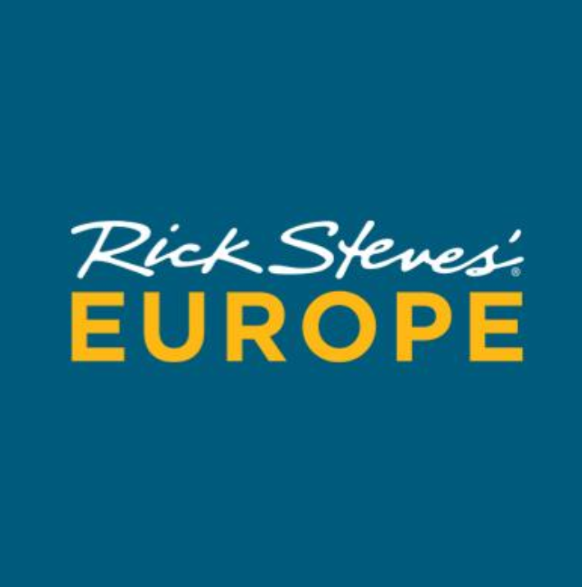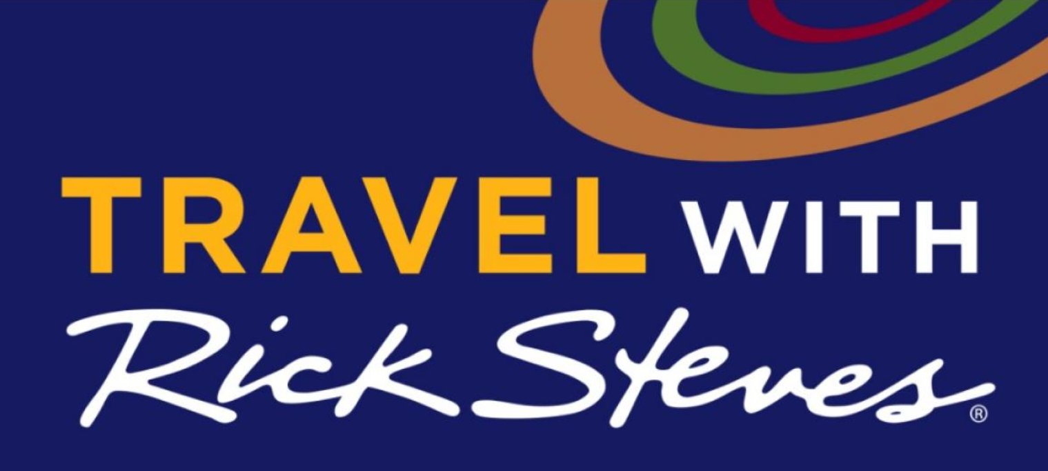  Rick Steves’ logos are simple, with a blue background and his handwritten signature, making him the centerpiece of the brand. There are few other slogans, symbols or brand call outs, other than his mission statement and favorite slogan to “Pack Light, Pack Light, Pack Light.” His personal signature is featured on his guidebooks and merchandise as well:  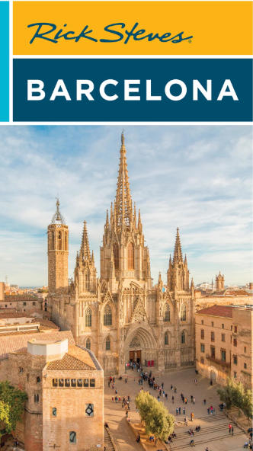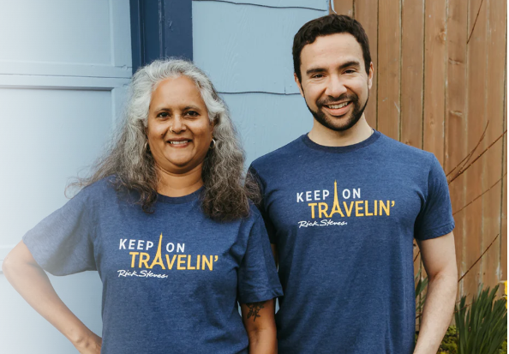  Source: ricksteves.com
Brand Portfolio | What are the company’s primary products, services, and solutions? What categories does the company use to organize these? By market segment? Product lines? Technologies? | The company’s primary products are guided tours to Europe and related content, including guidebooks, TV shows, radio programs, DVD’s and short form videos on his website and social channels.  The company also sells travel related merchandise like money belts, maps, and toiletry bags on its website and at its signature retail store in Edmonds, WA.

Current Brand Communication Strategies
Rick Steves is fortunate to have built up his fanbase and followers over several decades, with his guidebooks, PBS show and tours. His fans have followed him to Facebook and Instagram, where he has 1.3 million and 550 thousand followers, respectively. He has an army of content creators, who he’s likely interviewed over the years, sharing their informative videos across his channels.
These platforms allow him to constantly cross promote upcoming TV shows, social posts, books and travel trips.
Steves’ charges nothing for public broadcasters to air his programs and he posts all his programs online for free. Because of this robust earned and owned media ecosystem, he rarely buys advertising.

Source: A. Ragusea (2016), Current News for People in Public Media, Travel host Rick Steves describes a business model based on generosity

Insights and Recommendations
SWOT Analysis
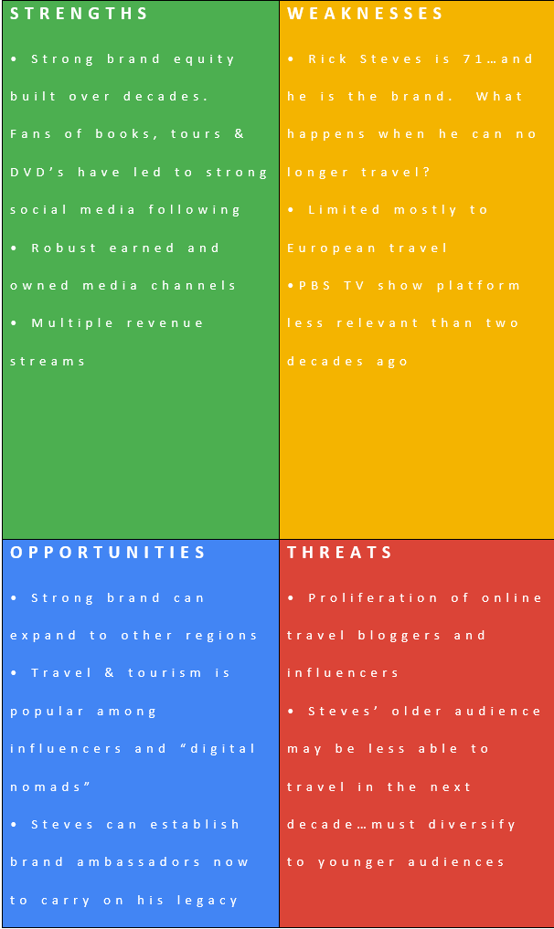
Rick Steves’ company came of age in the 1970’s, when several other budget travel books like Let’s Go and Frommers also emerged. Let’s Go is now defunct and Frommers survives but is much less prominent. What separates Rick Steves is his early adoption and distribution of his content across platforms such as PBS, DVD’s and later the web and radio shows. He also leads tours, rather than just writing about them, making him an early “influencer” before the term became popular.
Today the media landscape is awash in travel bloggers and influencers posting FOMO inducing content. What separates Steves is his personal touch and credibility, established through decades of dedicated writing, traveling and publishing.
However, Steves’ audience is likely in their 50’s and 60’s and will soon age out of their ability to travel. A brand refresh that capitalizes on his legacy, while contemporizing the brand for the next generation, will ensure his legacy carries on.

Refining Their Brand
If your brand was a season – what would it be and why? | Spring…because we’re always looking to discover something new.
If your brand could go shopping anywhere on an unlimited budget, where would it shop? | The Farmer’s Market in Paris, supporting and getting to know the locals.
What are 3 websites you love? These can be unrelated to the brand you selected. | https://www.frommers.com/  https://www.eatingeurope.com/  https://www.passportandpixels.com/best-travel-photography-blogs/
What colors do you think best suit the organization you have selected? When you think of this organization, what colors come to mind? See this psychology of color infographic for inspiration. | The company specifies Pantone 308 (blue) and Pantone 130 (gold) as its brand colors on its website. These colors convey the Mediterranean Sea, sandy coastlines and dusty arid climates around Southern Europe. These colors align with the joyful, fun and personal ethos the company conveys to its audience of travel afficionados.
Note at least 3 URLs or screenshots of logos that you like and consider aspirational for your re-imagined brand. | 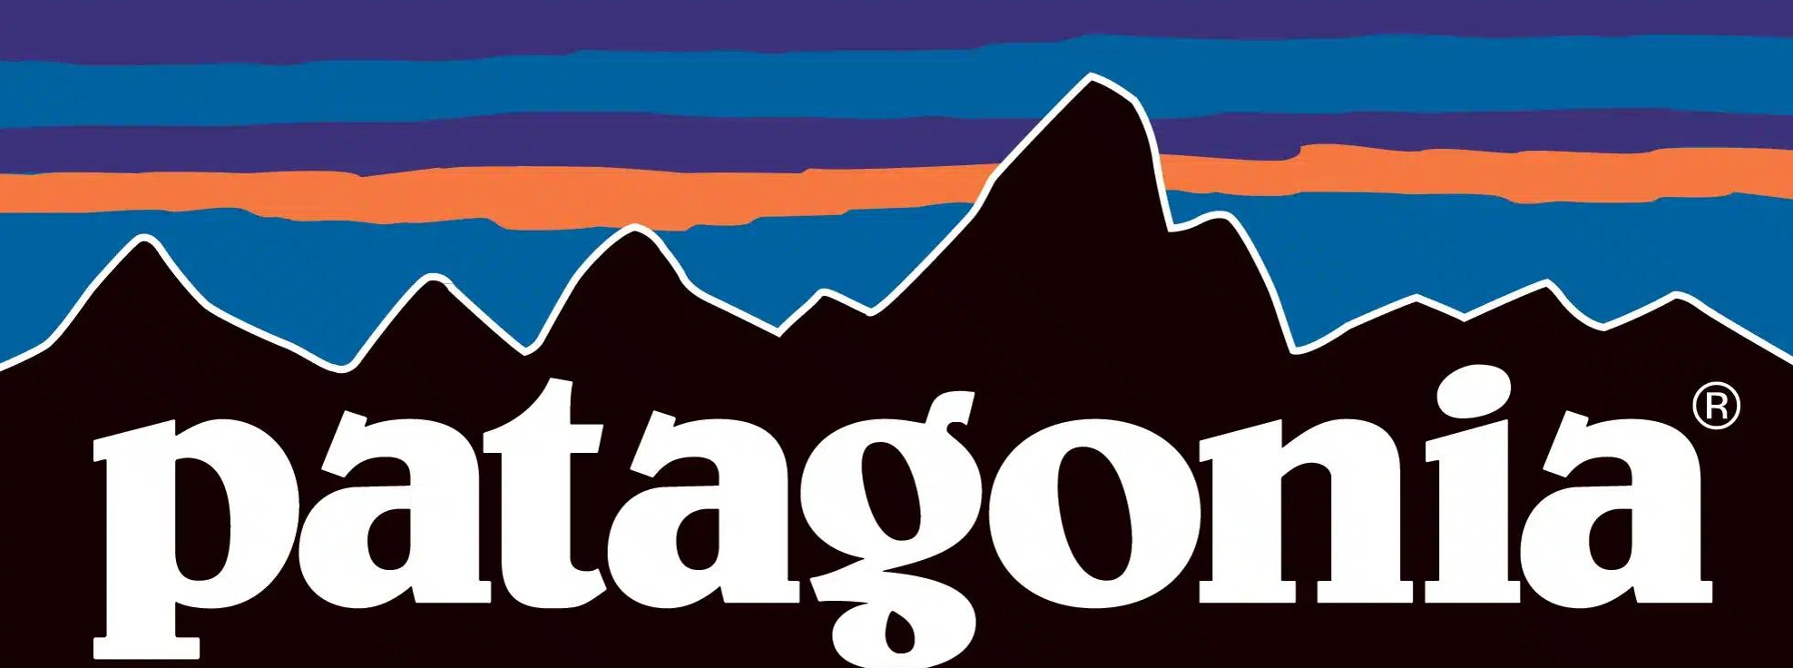  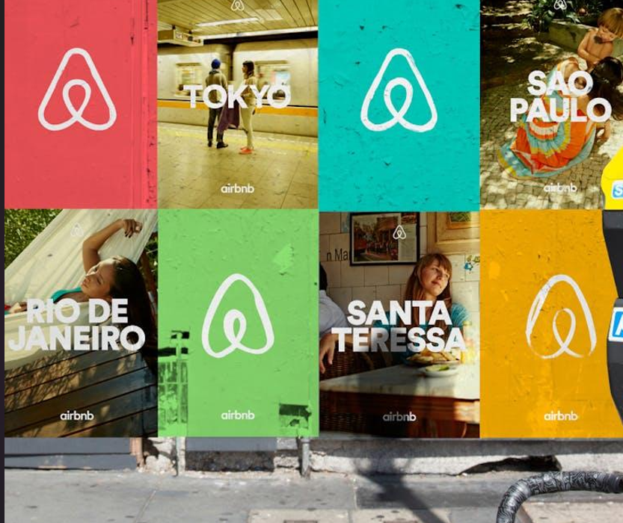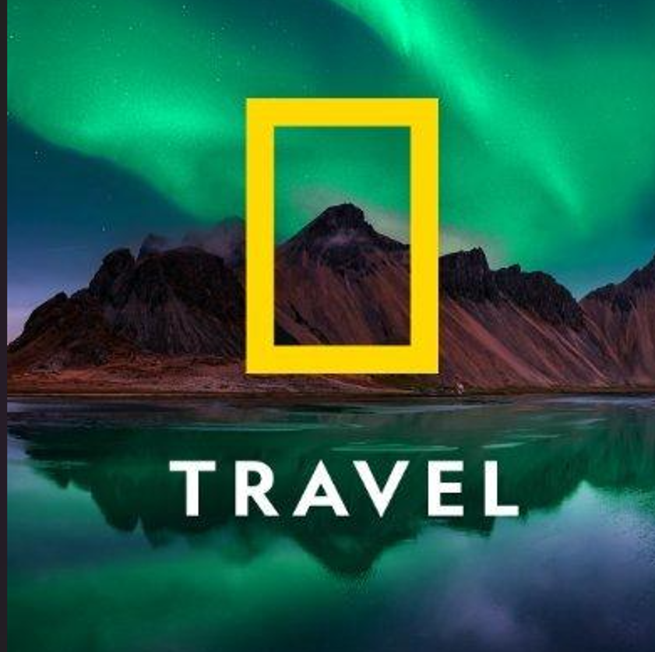
Note at least 3 URLs or screenshots of typography that you like and consider aspirational for your re-imagined brand. Use tools like fonts.adobe.com or fonts.google.com for inspiration. | - Louisville II – Fun and irreverent…can help contemporize the brand  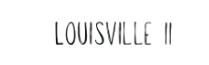  - Brixton Script – A little more formal but also fun  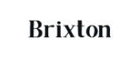  - Avenir- Feels like a postcard  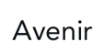  Source: Canva
Do you have any imagery ideas for your branding? Is there a photo style or illustrative approach that inspires you? Describe it and if possible, include links to examples. | The “Rick Steves Europe” brand is so strong, there’s an obvious opportunity to expand into other areas like South America and Asia. The blue box could also use a refresh, so shaping several logos into countries or continents while keeping the Rick Steves typography could help the company expand:  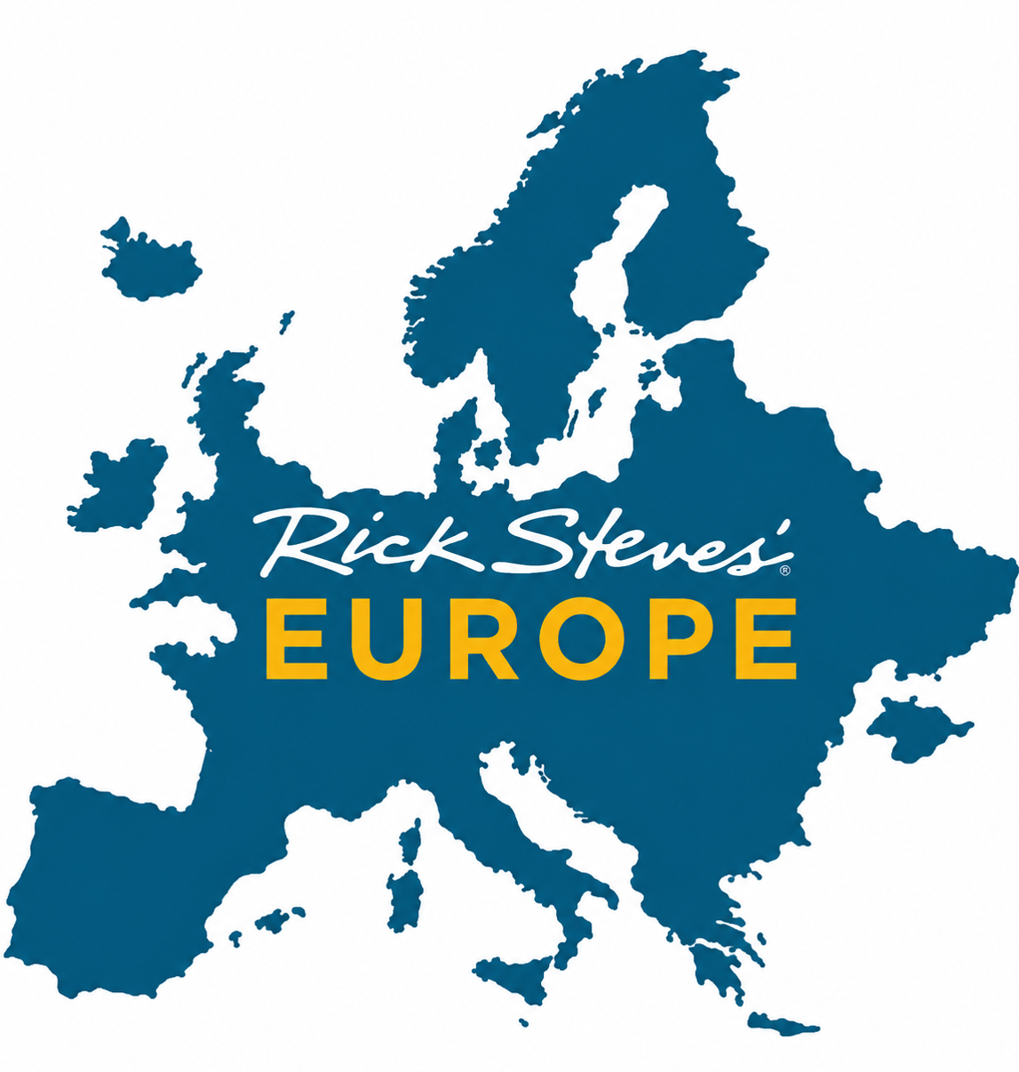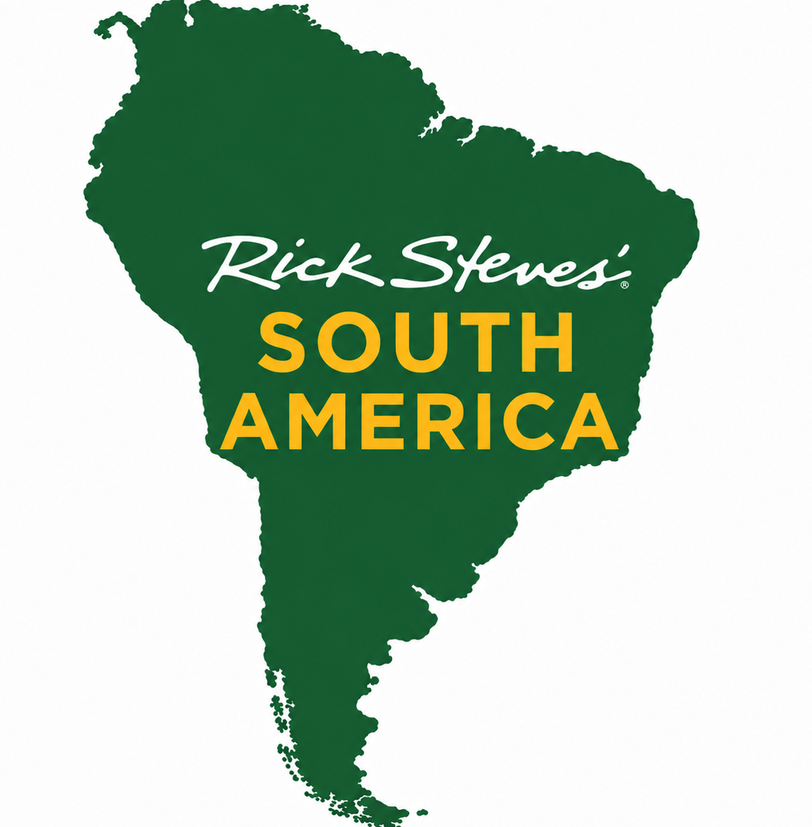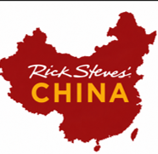  It’s likely Steves had considered this idea, but such expansion would require ambassadors beyond Rick himself, potentially diluting his personal touch that is so intrinsic to the brand.

Future Goals
In your own words, what does “success” look like in a refreshed brand for this organization? | A rebrand of Rick Steves would keep the personal, authentic ethos the brand has built over decades, while modernizing the look to be more contemporary. It would highlight his experience and authority, while also appealing to the next generation of travelers so the brand can continue to grow.
What type of customers could they be reaching that they are not reaching now? | The explosion of travel bloggers and influencers on social media shows the value of Steves’ brand. By contemporizing his look and feel, he can appeal to the “digital nomads” traversing the globe, who are likely tired of finding themselves in the same locals as their fellow bloggers.
What would you say are their greatest missed opportunities based on their current brand, business approach, or way they talk about themselves? | The opportunity to expand from Europe is immense, though likely limited by Steves’ preference to focus on Europe. However, he’s created a formula of travel inspired by cultural understanding that appeals to travelers everywhere.

Part Three: Customer Persona (aka “the ideal customer”)
Who is their dream customer? Give them a name. | Sally-Recently retired, in her 50’s, with a strong desire to travel in an authentic way. Still has the energy and means to travel without assistance and is willing to “pack light and pack right.”
Where does this dream customer hang out online? Where do they shop? What brings them joy? | Sally is mostly on Facebook when online, checking out photos of her grandkids and finding activities to do in her community, like volunteering, playing cards and folk dancing.
What do they do for a living? What is their income level? What kind of home do they live in? | Sally is recently retired, but volunteers in her community. She worked decades and saved so she could one day travel the world. She lives in a modest home in a retirement community in Arizona, which she purchased after selling her expensive home in Seattle. She has a retirement nest egg of over $1 million, and an income stream of around $10,000 per month.
What problems is your dream customer facing? What barriers may they have to purchasing from you, coming to your store, taking advantage of what you have to offer? | Sally is busy with all her activities, so travel requires planning. However, she and her spouse travel 5-6 times per year and want to visit as many countries as they can in the next decade.
What are your dream customer’s top 5 priorities? | - Staying healthy  - Staying active  - Getting to know her grandkids  - Maintaining lifelong friendships  - Keeping her mind and body active
What will these people be drawn to in your business? | The sincerity, authority and familiarity of Steves’ as a travel expert will appeal to Sally. She will appreciate Rick’s humility and willingness to take adventures, even though he is older than her.
What do you want your customer to feel when they see your brand? | Excitement to travel Europe and reassurance that Steves will guide them to mingle with locals, lounge in a vineyard and bask in the beauty of the Swiss Alps.

Part Four: Brand Refresh

Current Visual Identity
Logo
Font Suite | Font 1 (headlines)
Font Suite | There doesn’t appear to be an established font. The closest is SignPainter HouseScript  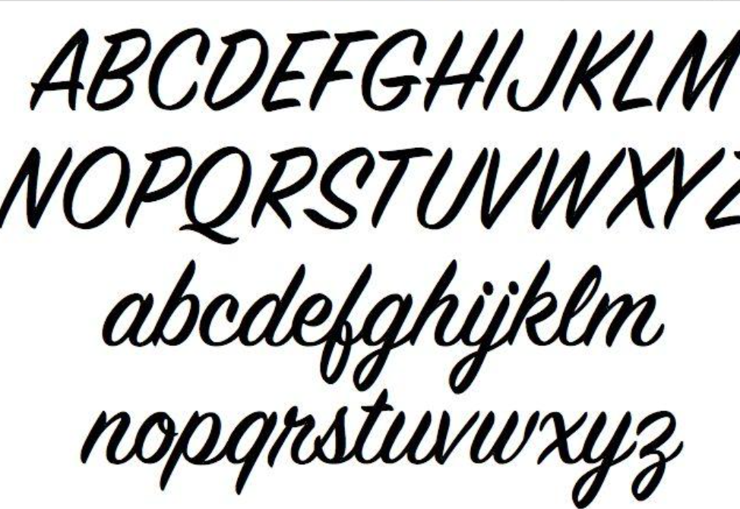
Color Palette | Primary | Secondary
Color Palette | Pantone 308 (blue) and Pantone 130 (gold)

Recommended Brand Refresh

Book Cover features Rick Steves’ original signature with Louisville II font in copy
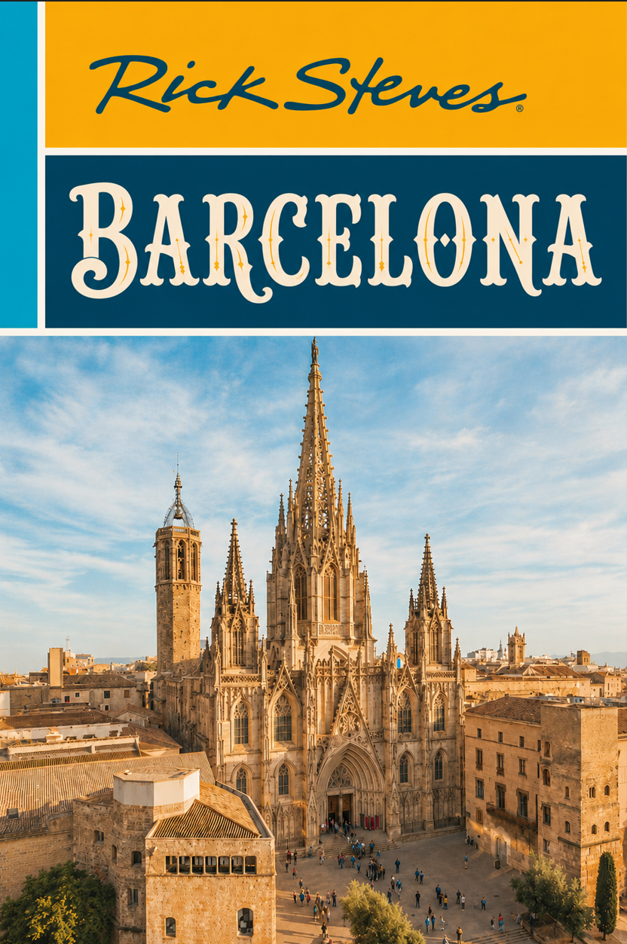
T-shirt & coffee mug feature new logos
